PROMPT® USER GUIDE
Welcome to Audacious Inquiry’s PROMPT®!
PROMPT® (Proactive Management of Patient Transitions) was developed to provide an easy-to-use interface for clinicians to access notifications and other information from the Encounter Notification Service® (ENS®). If accessing PROMPT as part of a HIE service, it can be accessed alongside other HIE services.

Who will use this Guide?
PROMPT User: A PROMPT User can access the Proactive Management of Patient Transitions application and view notifications for patients you have access to view.

Other Important User Roles
Organization Manager: An Organization Manager can add, update, and inactivate users for their organization as well as associate subscriptions to the appropriate users. Please see the PROMPT Administrator Guide for further guidance about Tenant Administration functionality.

PROMPT® USER GUIDE
TABLE OF CONTENTS

First Time Login 6
Password Reset 9
Using PROMPT® 13
Set Default Subscription 14
View Notifications 15
Notification Status 19
Notification Export 19
Notification Detail Sections 23
Event Details 23
Patient Information 23
Care Notes 23
Creating a Care Note 24
Event History 25
Filters 27
Filter by Name/MRN 27
Adding a New Filter 27
Editing a New Filter 28
Saving a Filter 29
Applying a Saved Filter 30
Applying a Saved Filter and a New Filter Together 31
System Automatic Handling of Duplicate Filter Conditions 31
Removing an Applied Filter 32
Editing or Deleting a Saved Filter 32
Duplicating a Filter 33
Deleting a Saved Filter 33
Viewing a Patient’s Care Teams 35
Submit Ideas to Audacious 37

PROMPT® USER GUIDE
ACCESS TO PLATFORM

First Time Login
To access PROMPT, your Administrator must create a user account for you. You will receive an email notification once an account has been created. Within the email, click the hyperlink provided. The link is only valid for an hour. If the link expires, click the “Forgot Password” link at the bottom of the login screen. Enter your username and click the “Request Password” button.
Tip! Make sure that the system email address support@ainqapps.com will populate to your inbox, so that emails for password resets do not end up in your junk / spam folder.
An email with a unique link will be sent to you to set your password. Enter in your new password following the password requirements then enter it in a second time. Once finished, click the “Submit” button.

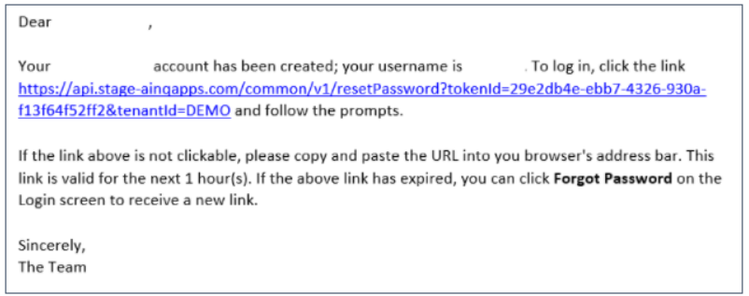
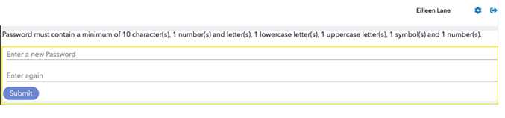
Please note the Password Requirements when creating your new password. Passwords must contain a minimum of 10 character(s), a combination of at least 4 numbers and letters. In addition, there must be a minimum of 1 number(s), 1 lowercase letter(s), 1 uppercase letter(s), and 1 symbol(s).
Once you have successfully created your password, you will be directed to the original PROMPT login page. Enter your username and your newly created password where indicated. When finished, click the “Login” button.
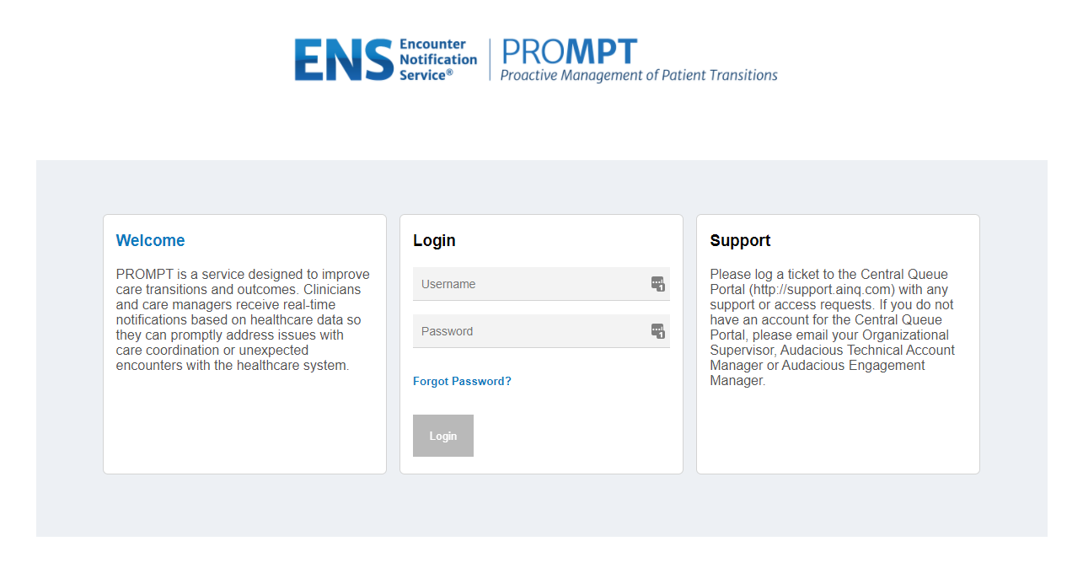

You will then be directed to the Terms & Agreements as shown below. Please read the Terms & Agreements for information regarding the uses of PROMPT. You will need to agree to the Terms & Agreements during your first login and any time the Terms & Agreements is updated. To navigate to the next page, click the “I Agree” button at the bottom of the page.

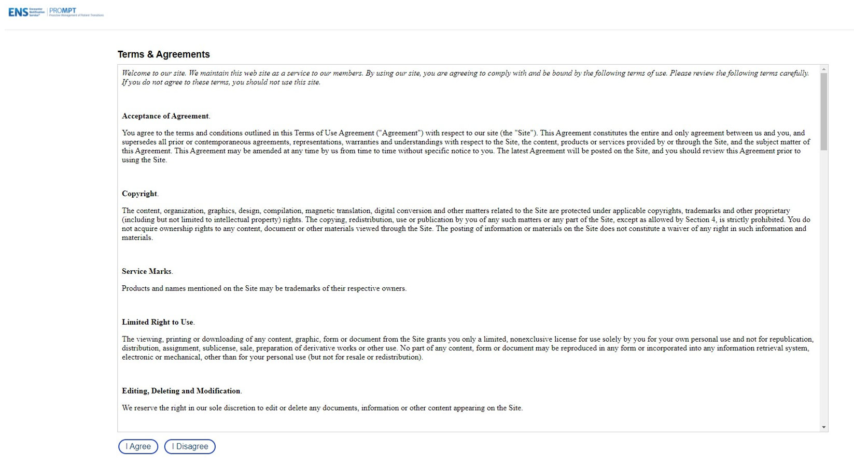

You will then be directed to the Security Question Page. Select three security questions from the drop-down options or write-up your own question(s) and enter your responses into the “Answer” field for each. Answers to the security questions are case sensitive. Once completed, click the “Save and Continue” button. These security questions will be used when you forget your password and need to reset it.
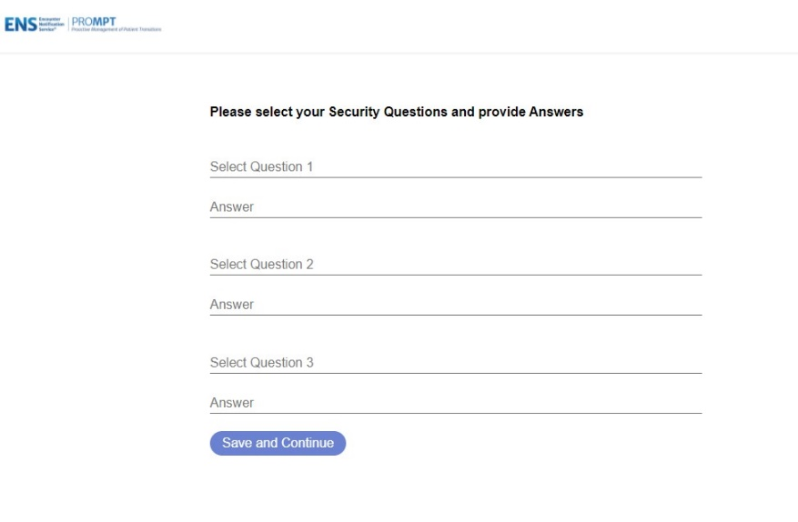

Password Reset
To reset a forgotten password, navigate to the PROMPT homepage, https://<customer>.ainqapps.com/login. Click the “Forgot Password” link on the login screen.
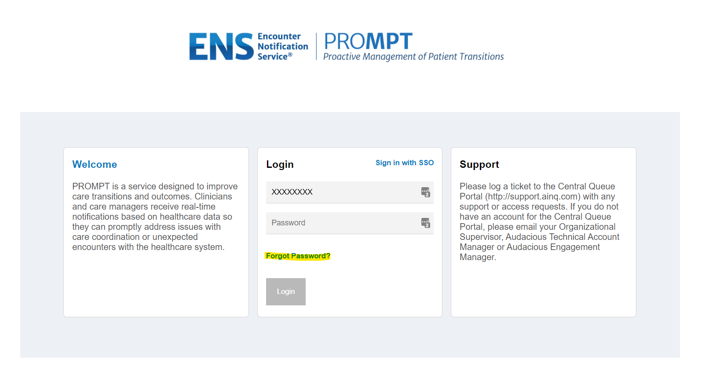

Enter your username and click the “Request Password” button.
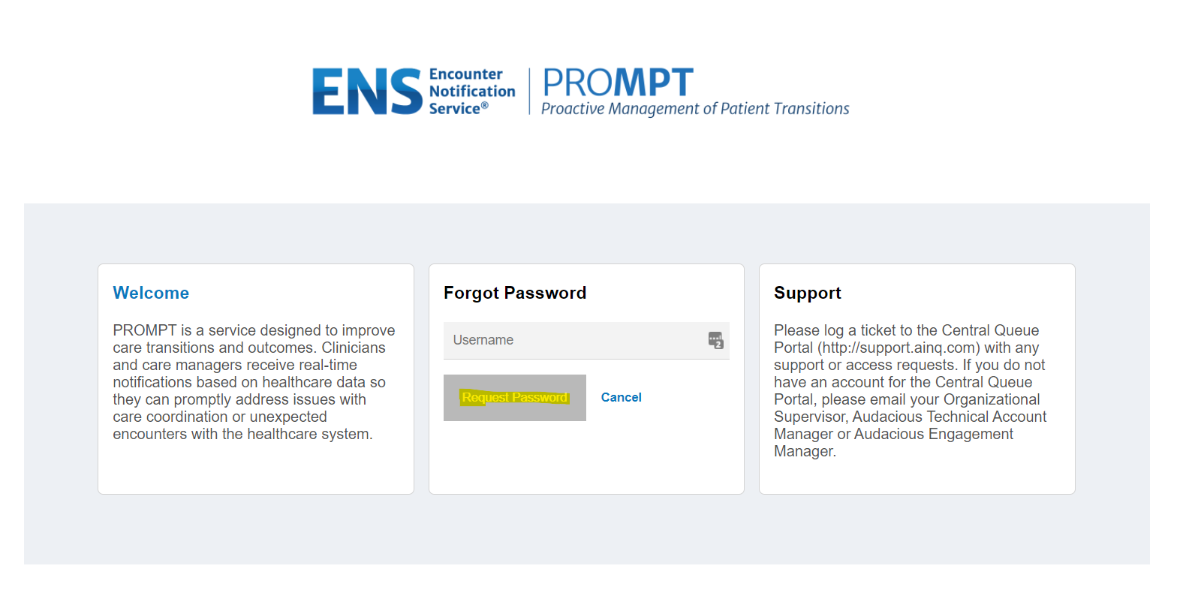
You will receive an email titled “Request to Reset Account Password”. Click on the hyperlink within the email.
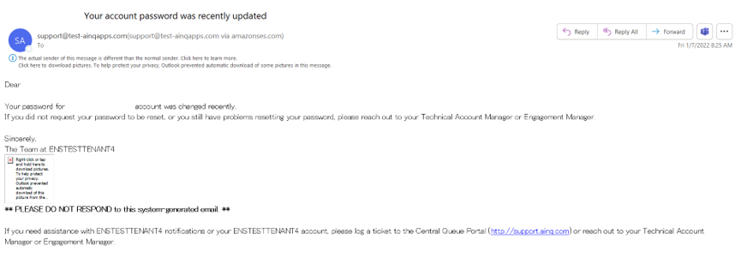

This will bring you to a page asking for the answer to one of the security questions you set up during the account creation process. Type in your answer. When finished, click the “Next” button.
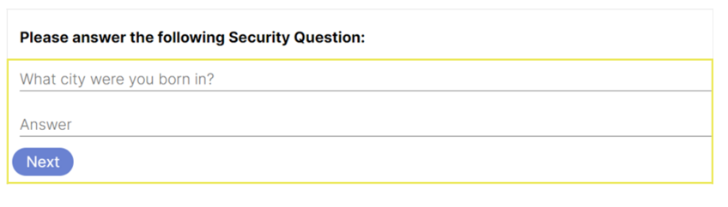
If you successfully answered the security question, you will be redirected to the Set Password screen, where you can create a new password (following the password instructions for length and type of character). Press the eye icon () to view the password you typed in. When finished, click the “Submit” button.

After clicking “Submit”, you will be redirected to the initial PROMPT login screen where you can enter your new password along with your username. This Password Reset workflow is available for users who have forgotten their password, but still know their username. If you forget both your username and password, please contact your Organization’s PROMPT Administrator or Point of Contact for assistance.

PROMPT® USER GUIDE
USING THE APPLICATION

Using PROMPT®
To use the PROMPT Application, enter your username and password and click the “Login” button. You will be logged into the Dashboard page. From the Dashboard, you can click the “Notifications” button to access all notifications you are subscribed to receive. If other services are available to you, they will also be listed on the Dashboard.
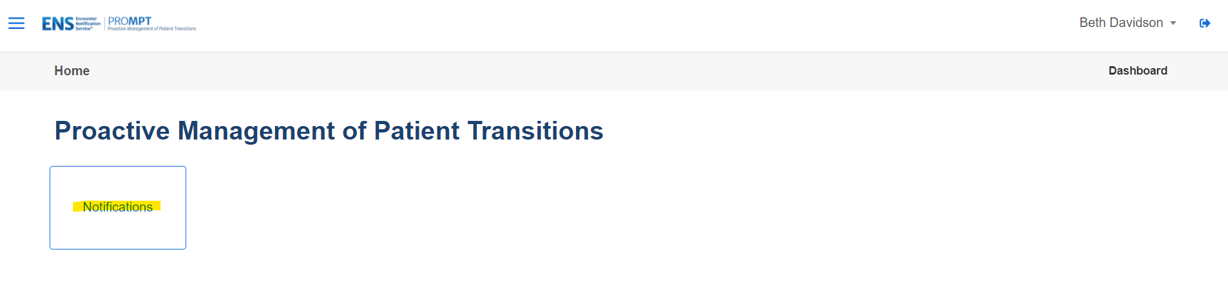

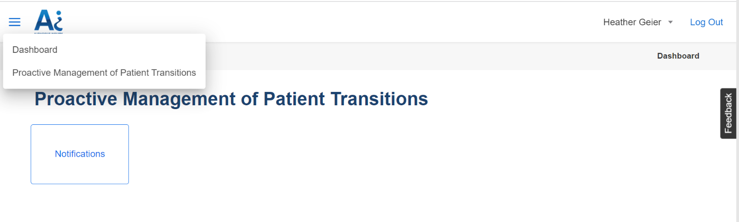
Another way to navigate is by clicking on the hamburger menu, the three horizontal lines icon (), to navigate to the Proactive Management of Patient Transitions (PROMPT) application page or the Dashboard page.

Click on the drop-down arrow icon () next to your name to select the option to reset your password and the “Log Out” link to log out of the system.
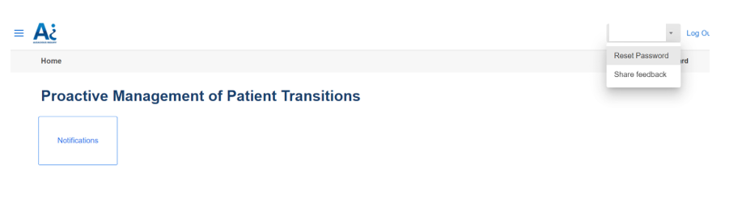

Set Default Subscription
When logging in for the first time, the system will ask the user to select the Subscription that will be the default subscription. This is the subscription that will be the defaulted subscription that will display in the subscription selection for the user.
Select the drop-down arrow and select the subscription from the list of available subscriptions then click the ‘Save’ button.
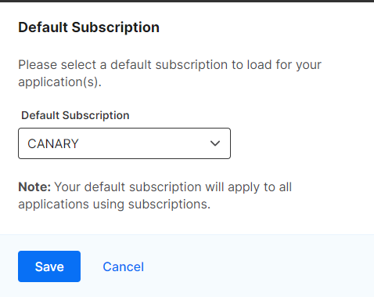

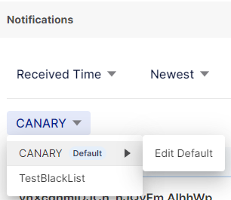
If the default subscription needs to change in the future, go to the subscription filter drop-down and the expanded option for ‘Edit Default’ next to the current default subscription.

View Notifications
Click the “Notifications” button from the Dashboard or select “Proactive Management of Patient Transitions” from the hamburger menu (). Both ways will open the PROMPT application to the Notification Home Page that will list all the notifications for the patients and subscriptions you have access to view.

The columns that display for the notification list are as follows:
- Patient Name
  - Gender and Age
- The Event Details icon (details in the next section of this user guide)
- MRN - this is your MRN for the patient
- Patient’s date of birth (DOB)
- Event Time – this is the date and time of the message’s event
- Facility – this is where the patient event occurred
- Event – this is the patient class (i.e. IP - inpatient, ER - emergency) and the type of event (i.e. registration, transfer, discharge) of the message
- Alert Type – the defined name of the SmartAlert rule that generated the notification. The general name for ENS notifications will display as ENS PROMPT or ADT Notification.
- Status – drop-down value that can be updated to reflect the basic status for each notification.
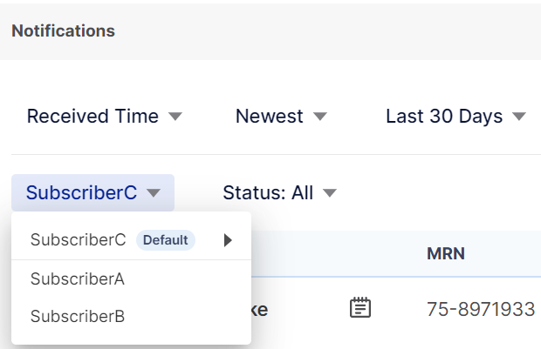
Notifications can be viewed only as one subscription at a time. If you have multiple subscriptions associated to your account, you can toggle to a different subscription by clicking on the drop-down arrow ( ) besides the selected Subscription name that displays just above the notifications list table.

By default, the last 30 days and all task statuses of notifications, based on the received date and time of the message, display with those most recently received displaying first (“Received Time”, “Newest”, “Last 30 Days”, “Status: All”).
Notifications can be sorted and specified by a specific date range based on a message’s date and time as well as the status of the notification’s task. A user can quickly modify the number or sort of the notifications being displayed based on the Received Time or Event Time, sorted by Newest or Oldest first, a date range, and the task status.

The available date range options are:
- Last 24 Hours
- Last 7 Days
- Last 30 Days
- Last 90 Days
- Last 180 Days

The available task status options are:
- All
- Not Started
- In Progress
- Completed

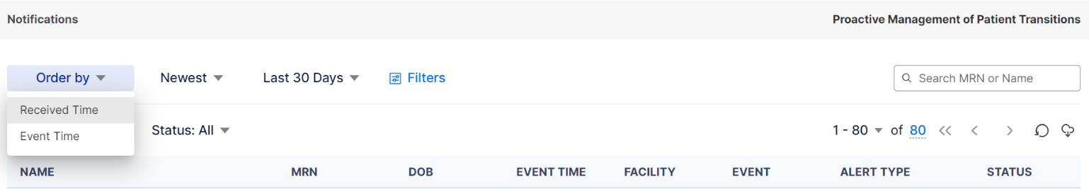
Select the drop-down arrow ( ) next to “Received Time” to change the sort to “Event Time”, the one next to “Newest” to change the order to “Oldest First”, the one next to “Last 30 Days” to change the date range selected, or the one next to “Status: All” to change the task status selected.

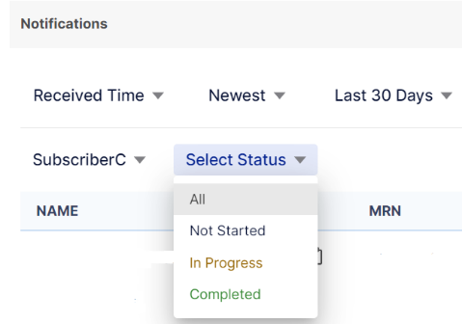
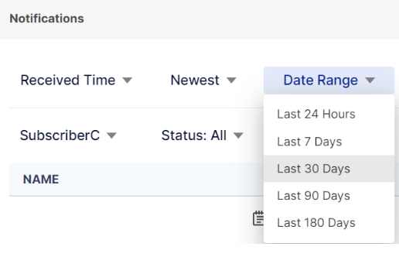
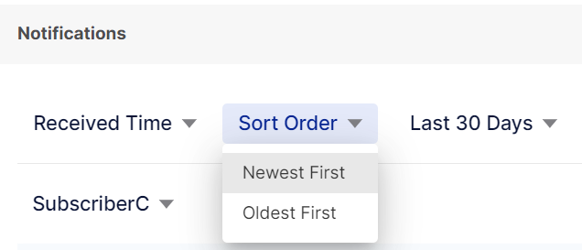

The total number of notifications for all your subscriptions displays in blue text towards the left-hand side of the screen above the table of notifications. When you hover the number, it will pop-up a small box with a date within it. That date represents the event date of the last notification that is in your list.
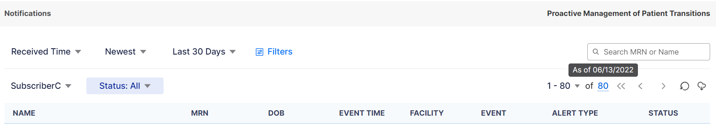
The list of notifications in the table defaults to 100 on a page. You can change the number that display on the page by using the drop-down arrow ( ) next to the “1 – 100” and selecting one of the other options available (20, 50, or 200).

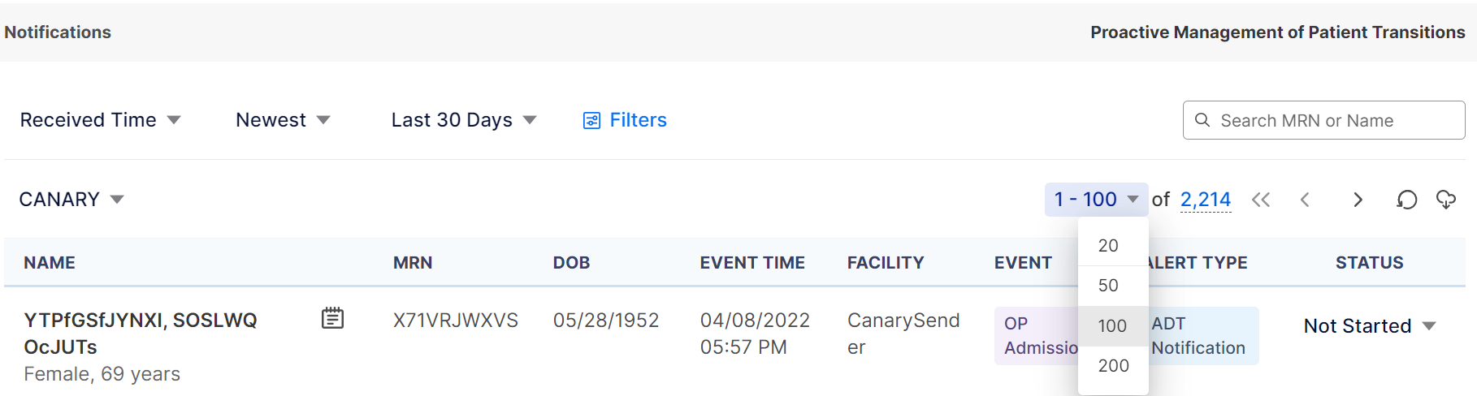

You can go to another page of notifications using the arrows () next to the total number of notifications at the top of the screen or at the bottom of the screen. The single left and right arrows () will move you to the previous and next pages respectively. The double left arrows ( )will move you back to the first page.
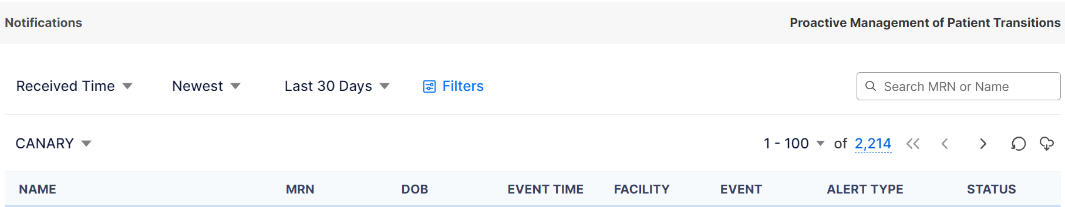

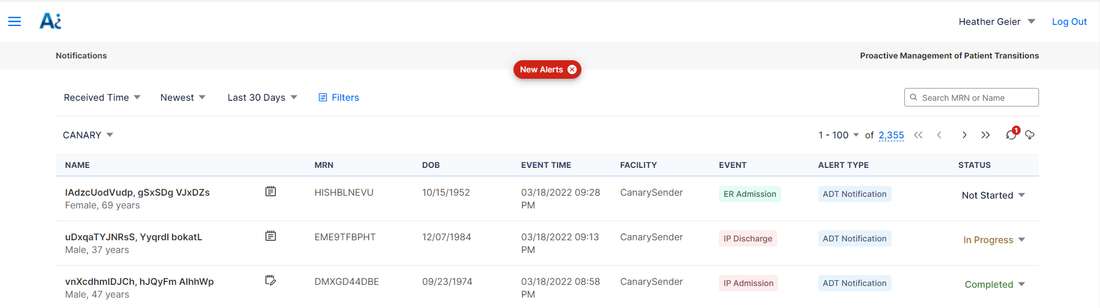
When new notifications are generated, an indicator of “New Alerts” will display at the top of the screen along with the number of new notifications on the refresh icon, circled arrow . The system will not automatically refresh the list of notifications until you are ready to view them, allowing you to continue with your work uninterrupted and not lose your place in your workflow. When you are ready, you can click on the refresh icon with the number of new notifications . When the new notifications appear in the list, a “New” indicator will appear briefly to the right of the patient’s name.

Notification Status
To view and update the notification status, toggle the values under the Status column on the Notification Home Page list view. The font color gives the user a visual indicator of the status. The status values and their colors are:
- Not Started is depicted in black text;
- In Progress is depicted in reddish brown text; and
- Completed is depicted in green text.
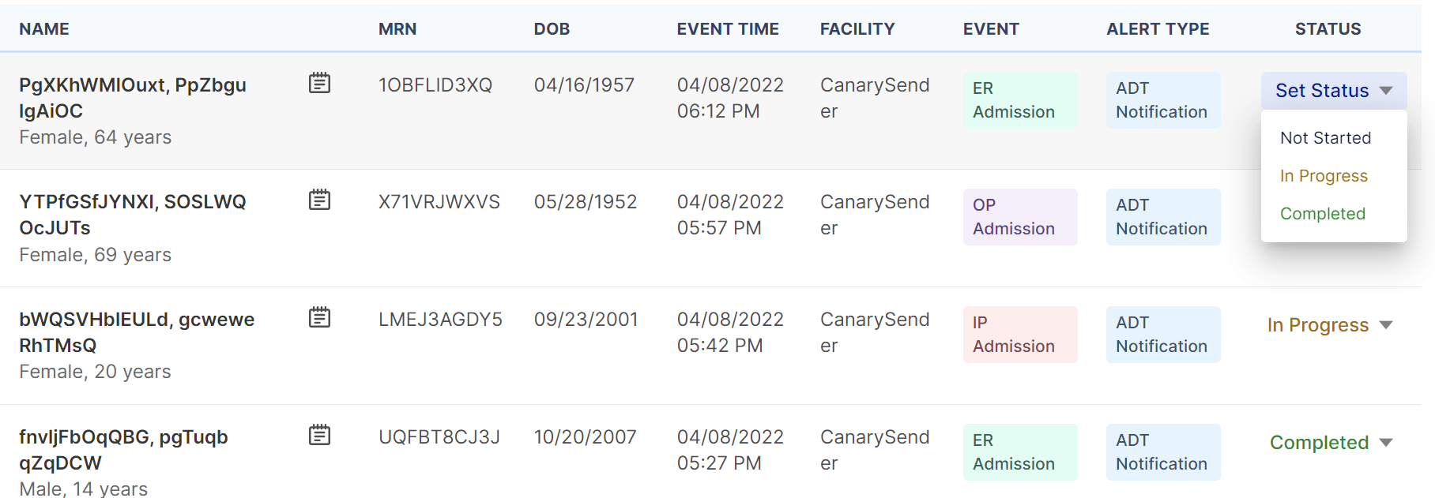

Notification Export
To initiate an export of the current list of notifications from the Notification Home Page, click on the export icon, a cloud with a down arrow ().
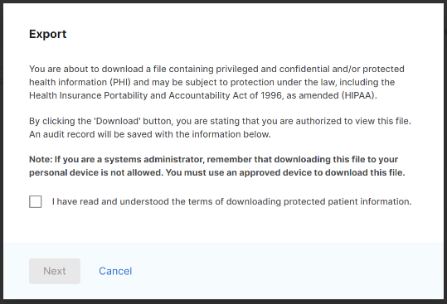
You will be presented with a window asking to acknowledge that PHI will be downloaded as a file onto your machine. Only after you check the checkbox next to ‘I have read and understood the terms of downloading protected patient information’ will you be allowed to proceed with exporting notifications and the “Next” button be enabled.

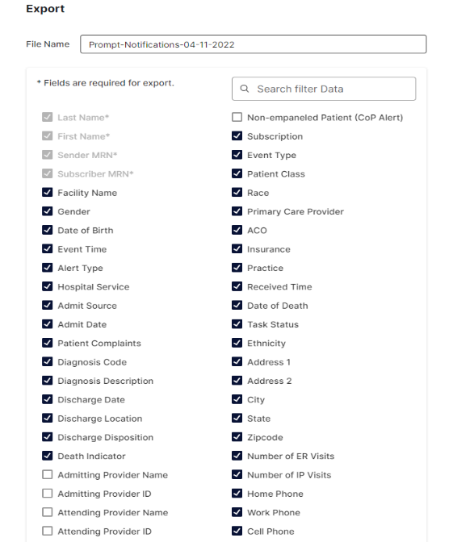
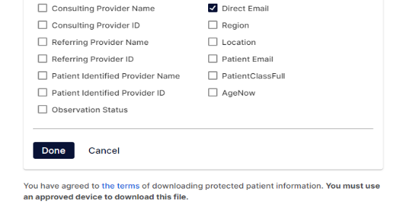
Once you check the checkbox and click the “Next” button, the Export window will appear and you will be asked to give the export file a unique name, define the export timeframe, and select the fields to be included in the export file. To define the timeframe, click on the Received Time/Event Time row to adjust the dates. To define the fields to be included in the export file, click the Event Details row and select or de-select the fields you would like to include. Click the “Done” button when finished in each section.

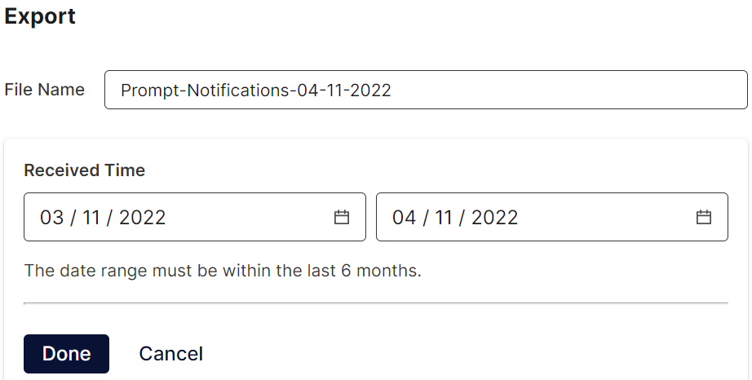

Once all export information is defined appropriately, click the “Export” button. This will initiate the export function and you will see a status update icon, a red spinning circle, display in the right bottom corner of the export icon ()and a message that will appear briefly above the list indicating ‘Exporting’ to show the export is in progress.
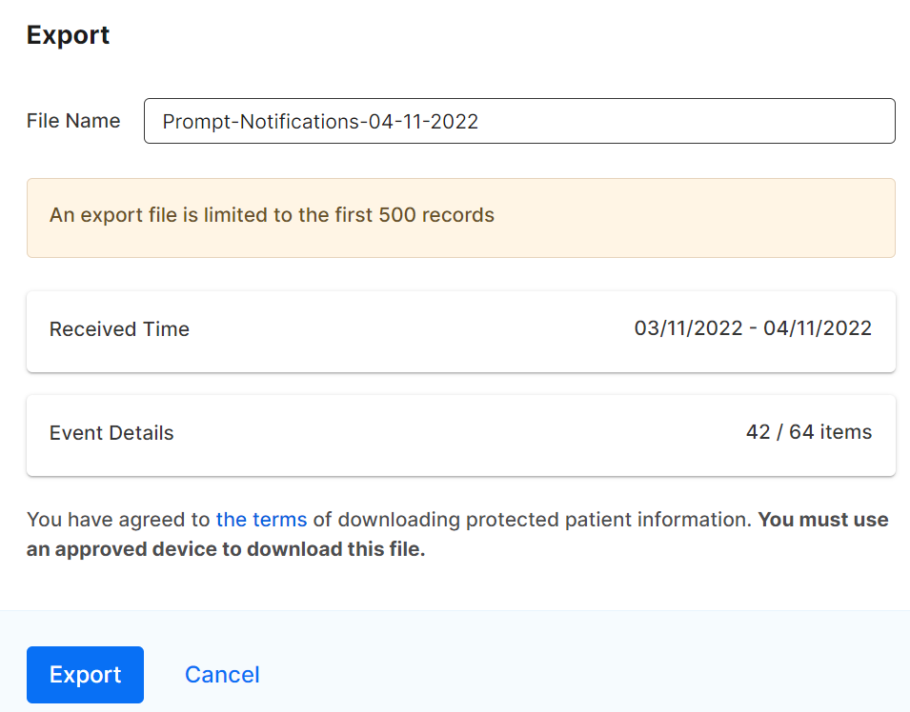
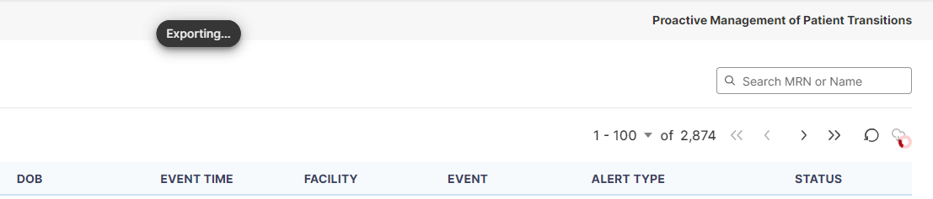

When the export processing is completed, the status icon on the export icon will change to a red circle with a white exclamation point () and a message will temporarily appear briefly above the list indicating ‘Export Completed’. To download the export file, click on the export icon() and click the “Download” button. To initiate a new export, as only one export file can be accessed at a time, you will have to download or delete the original export file first.
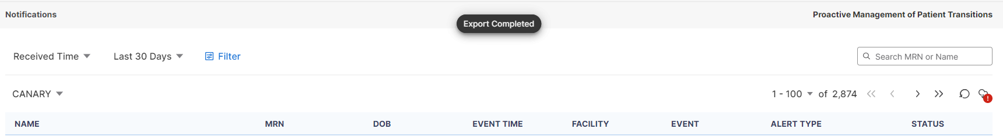

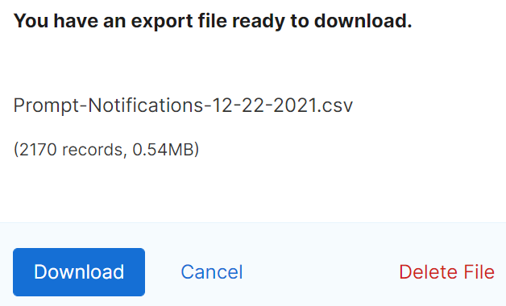

PROMPT® USER GUIDE
NOTIFICATION DETAILS

Notification Detail Sections
To view additional information about the notification, click on the Event Detail’s icon. The icon will display as either a spiral notebook paper with lines () or a spiral notebook paper with pencil () if there are care notes associated to the patient. There are four tabs within the notification details pop-up window: event details, patient information, care note, and event history.

Event Details
The notification details pop-up window will open to the Event Details tab. This tab will display additional information about the event that generated the notification and any additional specific subscriber information submitted with the patient panel that is not part of the Patient Info tab. The top section of fields will always remain the same but the fields that display in the Details section will reflect the appropriate fields for the Alert Type of the notification. For example, an Alert Type of a Readmission notification may have different fields display or a different order in which they display compared to an Alert Type of a disease-specific notification.

Patient Information
To view the patient information, click on the “Patient Info” tab. Information that was documented in the hospital’s message will display, such as the patient’s date of birth, address, ethnicity & race, phone and work phone numbers, and the hospital’s medical record number (Facility MRN). The subscriber patient information, if submitted with the patient panel, that will display on this tab includes the Emergency Contact, Primary Care Provider, Care Manager, and Insurance.

Care Notes
To view a list of care notes that have been entered for the patient for the last three months, click on the “Care Note” tab. All care notes that have been entered for the patient and are viewable for the user will display in the table with the date the care note was entered along with a preview of the note.
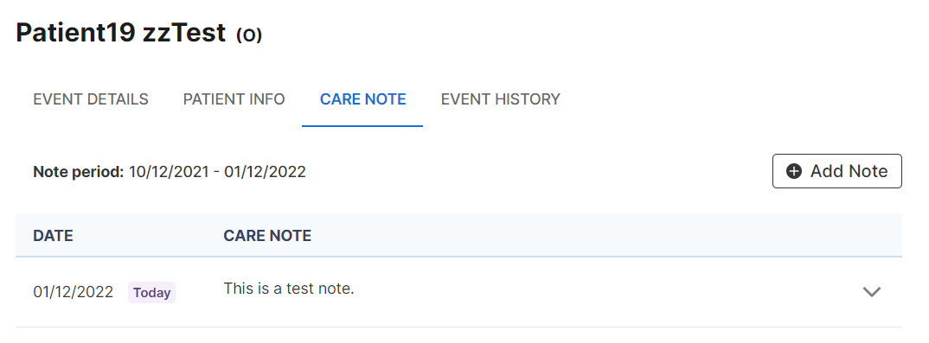
To view additional information of a care note, click on the individual care note or the expand icon, a down arrow (), next to the care note.

Creating a Care Note
Click on the “Add New” button to create a note. Type in the text information for the note and then click the “Save Note” button. The note will display for the patient across all notifications and for all users associated to your subscription.
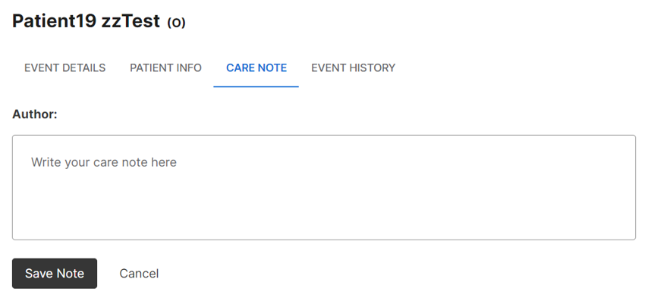

Event History
To view a list of event history for the patient within the network, click on the “Event History” tab. Event History displays a high-level event history list of all events for a patient for the past three months and will include the following event types: Admission (A01), Transfer (A02), Discharge (A03), Registration (A04), Status Change Outpatient to Inpatient (A06), Status Change Inpatient to Outpatient (A07). For each item, the event [date and] time, [patient class and] event type, complaint, and facility display on each row.
To view additional information about an event, such as the diagnosis code, diagnosis description, and discharge disposition, click on the expand icon, a down arrow (), for each event history row.
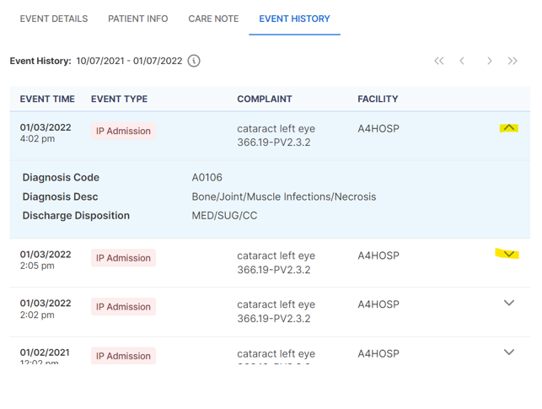

PROMPT® USER GUIDE
FILTERS

Filters
You can filter the notifications via two ways – Filter by Name/MRN and Filter by additional fields. Each way can be individually applied or both together.

Filter by Name/MRN
To filter the list of notifications based on a patient’s name or MRN, type the information into the ‘Search MRN or Name’ text box that displays on the right-hand side of the screen. Once you have entered in the information to search by, hit the <enter> key to execute the refinement on the list of notifications.
To remove the Name/MRN filtering, click back in the text box and a “x” will appear in the right-hand side of the box. Click the “x” and the name/MRN applied filtering will be removed from the list of notifications.

Adding a New Filter
To add a filter, click on the “Filters” button then the “New Filter” button. Select the drop-down options to build your filter. You can add multiple fields to refine the list of notifications by, as well as adding multiple conditions for some fields. Click the “Add Another” button to display a new filter by set of fields. Each Filter By set of fields must be filled out before applying or saving the filter.
When building a new filter, we do not recommend utilizing the fields “Event Time” and “Received Time” together within one filter. You will see “Event Time vs. Received Time” message appear with an information icon, an “i” in a circle (), next to it. When you click on that icon, a pop-up will display letting you know that using these fields separately allows for the best filter results and gives the definition of each field.
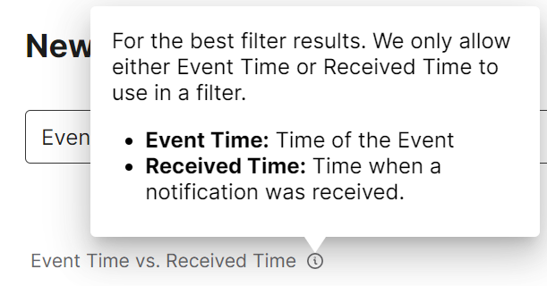
Once you have added and selected all conditions and values, click the “Apply” button at bottom of pop-up window to apply the selected criteria. The notifications will be refined based on the criteria applied. These applied filter criteria will display above the list of notifications.
If you do not wish to apply the filter, click the “Cancel” link to exit out of the New Filter pop-up window.
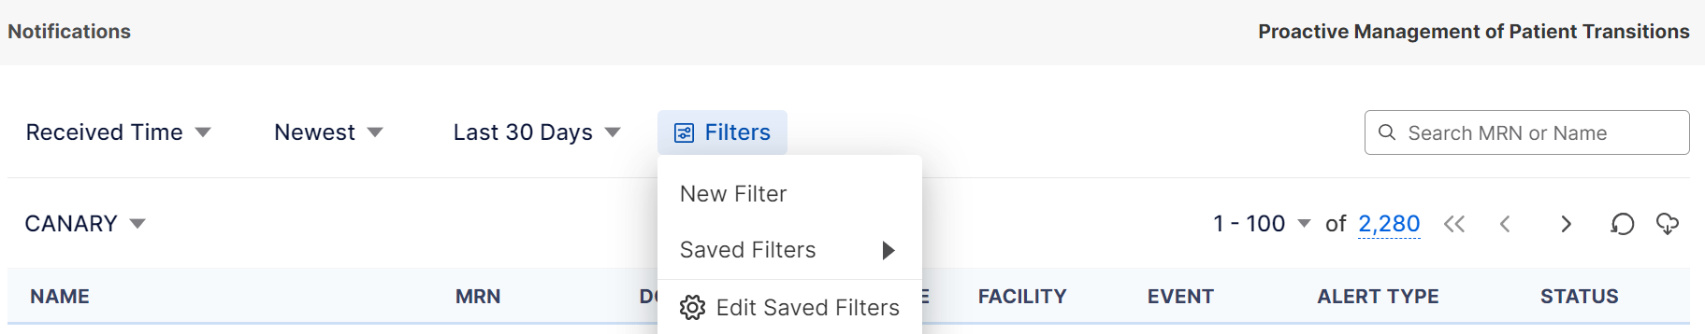

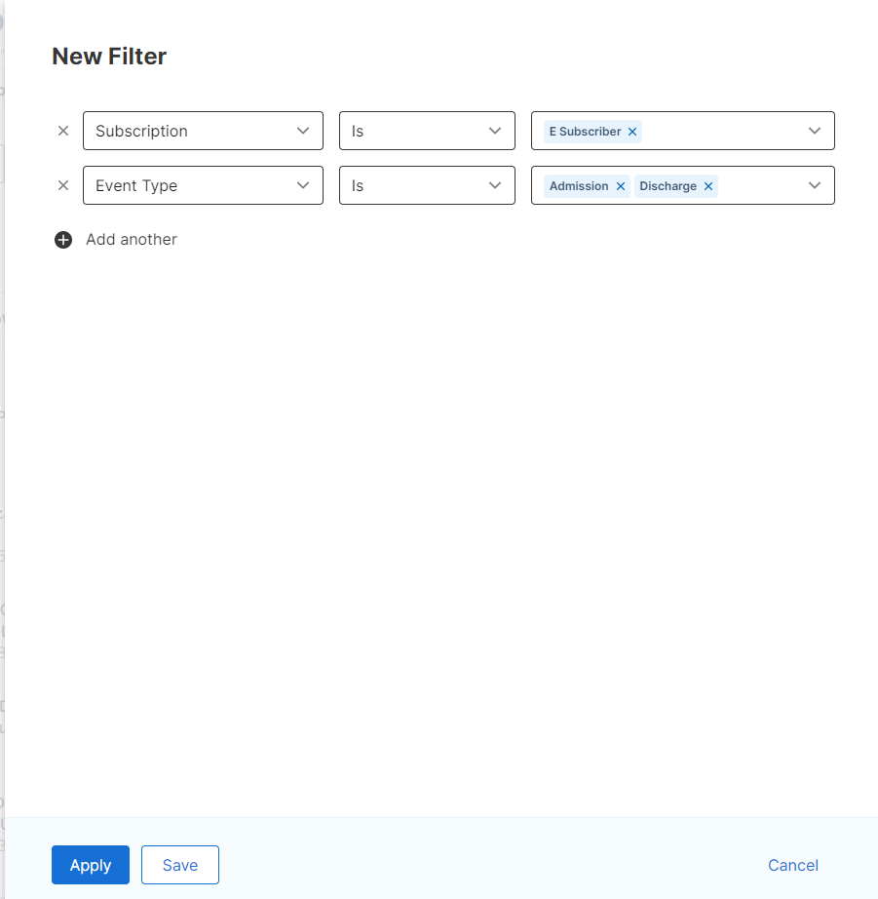

Editing a New Filter
After a new filter has been built and applied, you can continue to edit the applied criteria if need be. Click on the “Edit” link that appears next to the applied criteria. The criteria that you had already selected and applied will appear in the New Filter window. You can then add additional filters by field conditions, remove field values, and/or edit the currently built fields, operators, and values. Click the “Apply” button to apply the newly selected conditions to the list of notifications.
If you simply want to remove a specific applied condition, click the red “X” that displays within the appropriate condition to remove just that applied condition.
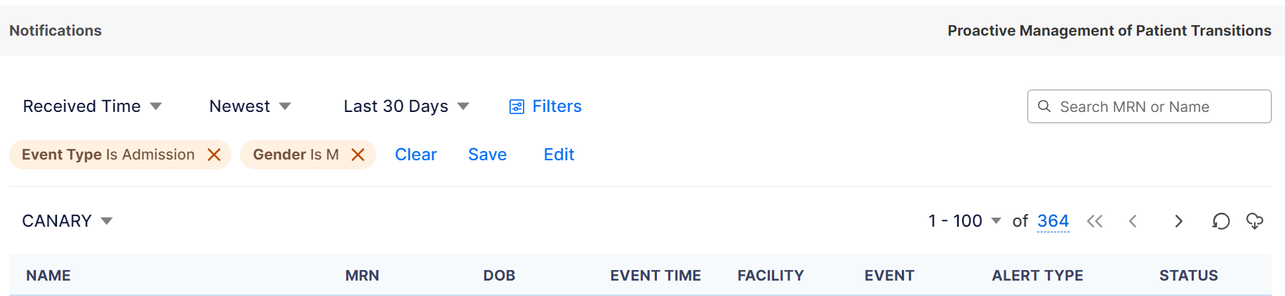

Saving a Filter
When building a new filter, you can save it so that you do not have to rebuild it every time. You can save a filter during two different steps in the process. First, you can save the filter when you initially build a new one or second, you can save it after building and applying the filter conditions. Filters are saved at the user level and are not associated to a specific subscription.
To save a filter during creation, click the “Save” button instead of the “Apply” button. This will bring up a new window to name your filter. Enter a filter name that is at least 3 characters in length and then click the “Save” button. This will both save your filter for later use as well as apply the condition(s) to the list of notifications.
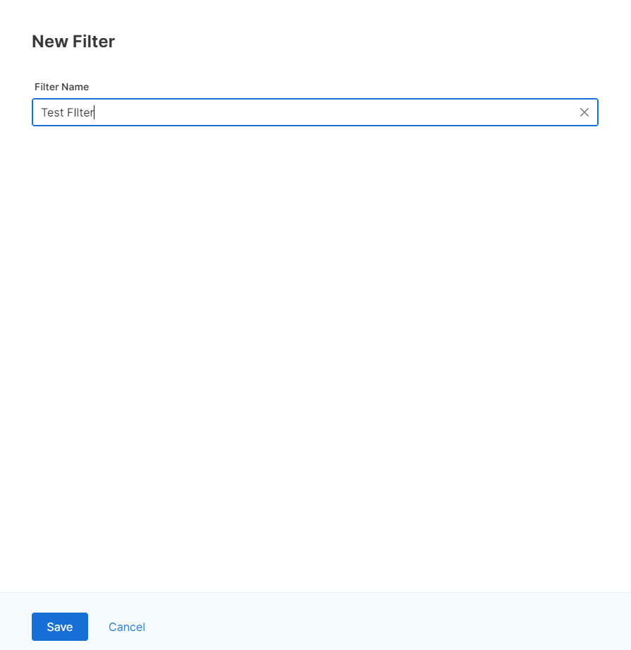
The second way to save a filter is after at least one condition has been applied, not from a saved filter, a “Save” link will display next to the applied condition(s). Click this link and it will bring up the New Filter window with the applied conditions. Click the “Save” button and enter a filter name that is at least 3 characters in length and then click the “Save” button again. This will both save your filter for later use as well as apply the condition(s) to the list of notifications.
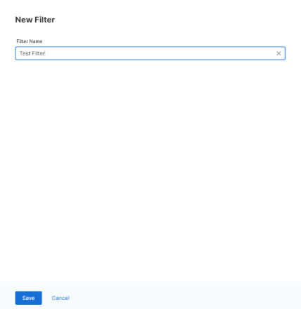
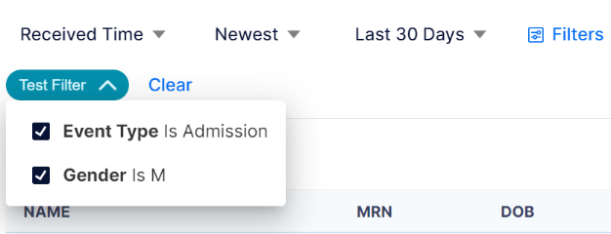

Applying a Saved Filter
If you have a saved filter and wish to apply it to the notifications, click on “Filters” -> “Saved Filter” -> [name of the filter you wish to apply].
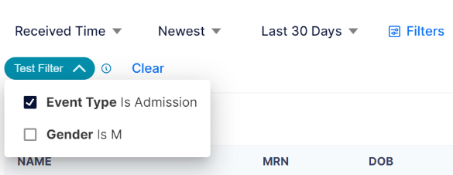
Once a filter has been applied, you will see the saved filter’s name above the table of notifications in a teal bubble. Within that bubble, a down arrow will display next to the name. You can use that arrow to expand the window to show all the conditions that are included in that saved filter. You can uncheck any of the conditions to un-apply the condition(s) if you wish to only apply some of the conditions within that saved filter. This allows you to utilize a saved filter instead of building a new filter. When you turn off any of the conditions within the applied save filter, an information icon, an “i” in a circle (), will appear beside the applied saved filter. When you click on that icon, a pop-up will display letting you know that one or more of the saved filters is turned off.
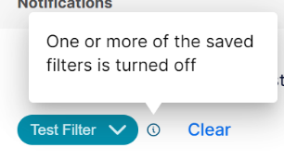

Applying a Saved Filter and a New Filter Together
You can use a combination of a Saved Filter and a New Filter rather than having to start from scratch. The order in which you apply the filters (saved vs new) does not matter. Follow the steps above in the sections ‘Applying a Saved Filter’ and ‘Adding a New Filter’. Once the new set of criteria has been applied, you can save both the new criteria and saved criteria to a new filter by following the steps above in the section ‘Saving a Filter’.

System Automatic Handling of Duplicate Filter Conditions
When the exact same value and logic condition has been selected and applied within a new filter and a saved applied filter, the duplicate will automatically be temporarily turned off in the saved filter and a message will appear briefly to let you know.
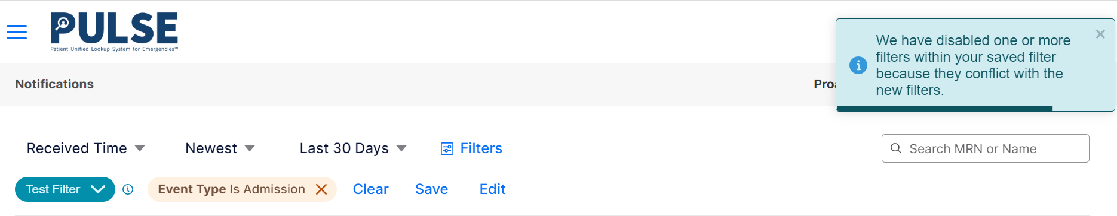
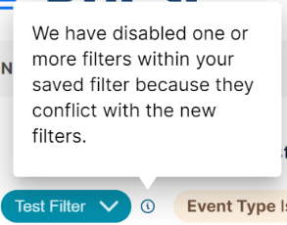
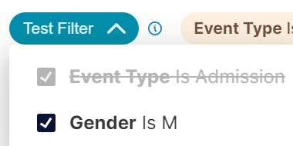

Removing an Applied Filter
Once a filter is applied, you can remove all applied filters by clicking on the “Clear” link. This will remove all applied criteria, except any name and/or MRN applied condition(s) and reset the list of notifications back to displaying all the notifications.
If a new filter was applied with multiple criteria, you can remove individual criteria above the filtered list by clicking the red “X” next to the appropriate criteria to remove.

Editing or Deleting a Saved Filter
To edit a previously saved filter, click on “Filters” -> “ Edit Saved Filters”. From the list of saved filters, click on the ellipsis icon, three dots in a line (), next to the filter you wish to edit and click “Edit”. You will not be allowed to edit a filter that is currently applied. To edit the filter, you will need to remove the applied filter first and then you can edit it.
Once in the edit mode, you can add or remove filter criteria or rename the filter. Once you have made all necessary changes, click the “Save” button.
You can also delete the saved filter from this screen as well by clicking the “Delete” button.
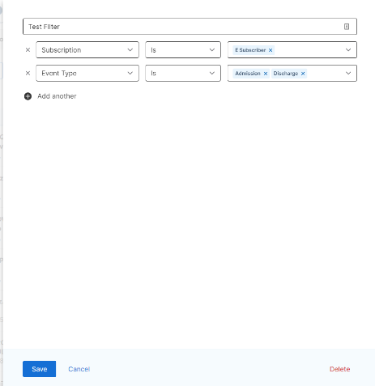

Duplicating a Filter
To create a duplicate of a saved filter, click on “Filters” -> “ Edit Saved Filters”. From the list of saved filters, click on the ellipsis icon, three dots in a line (), next to the filter you wish to duplicate and click “Duplicate”. A new filter is created in the list with a “-copy” appended to the original filter name. You can then choose to ‘Edit’ the new filter under the ellipsis icon menu. You can change the name of it and/or modify the filter conditions selected.

Deleting a Saved Filter
To delete a saved filter, click on “Filters” -> “ Edit Saved Filters”. From the list of saved filters, click on the ellipsis icon, three dots in a line (), next to the filter you wish to delete and click “Delete”. A Delete Filter confirmation window will appear. Click the “Delete” button to confirm deleting of the saved filter, removing the filter from the saved list of filters, or click the “Cancel” button to not complete the delete action and go back to the Saved Filters list.
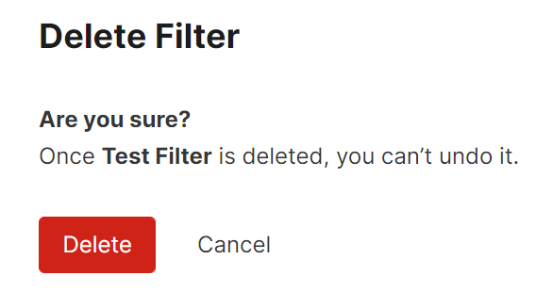

PROMPT® USER GUIDE
CARE TEAMS

Viewing a Patient’s Care Teams
To view a patient’s associated list of care teams, click on the patient's name from the notifications list on the Notification Home Page. The Patient Summary page with a list of care teams or subscribers will display. Care teams and subscribers are ordered by their updated date with most recent ones displaying first. Only the top five are shown in the initial table. To view the entire care team list can click the open in a new window icon, a square with an arrow coming out the upper right-hand corner ().
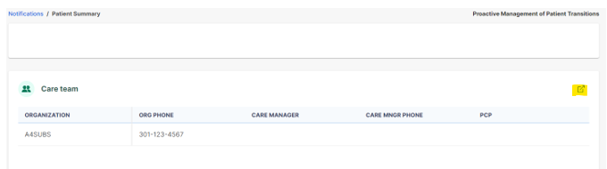
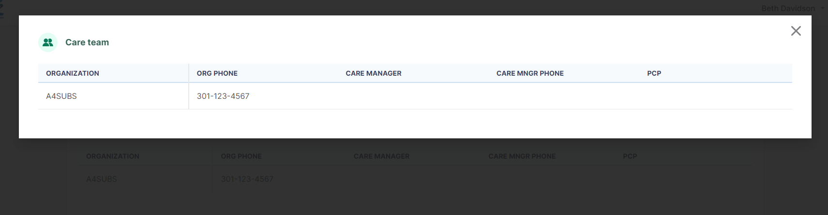

To go back to the Notification Home Page, click on the “X” link in the upper right-hand side of the screen.
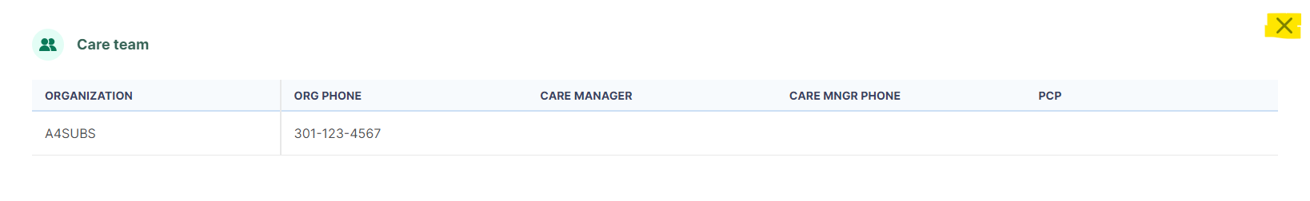

PROMPT® USER GUIDE
AUDACIOUS IDEA PORTAL

Submit Ideas to Audacious
You will be able to share with the Audacious team, an idea about a PROMPT feature you’d like to see by going to the user profile in the upper right-hand corner of the screen, when a user is logged in, and click on ‘Share Feedback’.
